**BrewPi LCD Shield Instructable**

If you’re interested in adding an LCD screen, Bluetooth connectivity, a rotary encoder to control your BrewPi without having to open up your Raspberry Pi, or all of the above, the BrewPi shield is an easy way to add the functionality without having to know or understand electronics. The shield was based on the work of day_trippr on Homebrewtalk.com and his LCD and Bluetooth “how-to’s”. The shield simply takes his protoshield design and incorporates it into a printed circuit board that you can more easily solder up.

**Ordering a PCB Board**

The first thing you’ll need is a PCB board. You can download the files here (<https://drive.google.com/folderview?id=0BwakCoACNDsmSWNQeS0xNVBBRFk&usp=sharing>), or you can go straight to OshPark and access the project here (<https://oshpark.com/shared_projects/rcOadziH>). The files are in Eaglesoft and are the board and schematic files. You can use these files to order boards directly from OshPark or Dirt Cheap Boards. If you go to other board houses, you’ll likely need to create a Gerber file to order boards. There are numerous resources on the web for how to create Gerber files.

OshPark and Dirt Cheap Boards both charge approximately $25 for a run of boards. At OshPark, you’ll get 3 for that price. At Dirt Cheap Boards, you’ll get anywhere from 9 to 11, depending upon their manufacturing run that day. You’ll need one board for every instance of BrewPi you would like to build.

**Components**

Once you have the board, you’ll need to populate it with the following components. You’ll also need male pin “breakaway” headers and stackable headers. You can find Arduino Stackable Headers at Adafruit.com, but any long male pin headers will work. The list below is just the shield components. You’ll need an LCD screen, Bluetooth module, rotary encoder, and whatever other components you need to build your custom BrewPi box.

|  |  |  |
| --- | --- | --- |
| **Part number** | **Part type** | **Value** |
| C1 – C7 | Capacitor | .1uF |
| C8 | Capacitor | 1.0uF |
| R1 | Trimmer Resistor | 10k, three lead trim pot – offset leads |
| R2 – R5 | Resistor | 10k ¼ W |
| R6 | Resistor | 4.7k ¼ W |
| R7 | Resistor | 1K ¼ W |
| R8 | Resistor | 2K ¼ W |
| R9, R11 | Resistor | 220 ¼ W |
| R10 | Resistor | 20 ½ W |
| D1 – D2 | Diode | 1N4007 |
| U1 | IC | 74HC595N – optional but recommended, an IC socket for mounting on the board |
| U2 | P-FET | BSS84 |

**Assembly**

When you have your board and components, let the assembly begin! Here’s your empty board. Clean up any rough edges of the board with side clipping pliers and sandpaper.

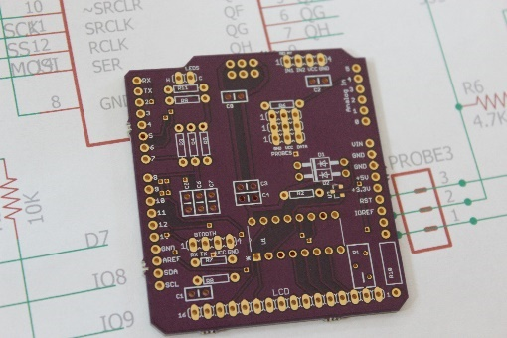

There are many references for soldering up electronics on the web. You can find inexpensive soldering irons on Ebay or Amazon. I have found that a good soldering station with a holder for the iron, a small tip for the iron, a place for a wet sponge and a variable adjustment on the heat are all you need. Add to that some flux, a pair of needle nosed pliers, some side cutting pliers, and a “third hand” with clamps and a magnifying glass all come in handy and are useful on this project and others you will undoubtedly tackle in the future.

**P-Fet**

The first component I start with when soldering the board is the P-Fet. It is indescribably small. Sure, you could measure it and then describe how small it is in millimeters, but that does not do it justice. They arrive in a small protective pack. Even the pack is small, and getting it open without damaging the tiny guy inside is a challenge. If you get it open and haven’t dropped it into your 1970’s shag carpet, you’re well on your way to success.

Here it is in relation to the board.

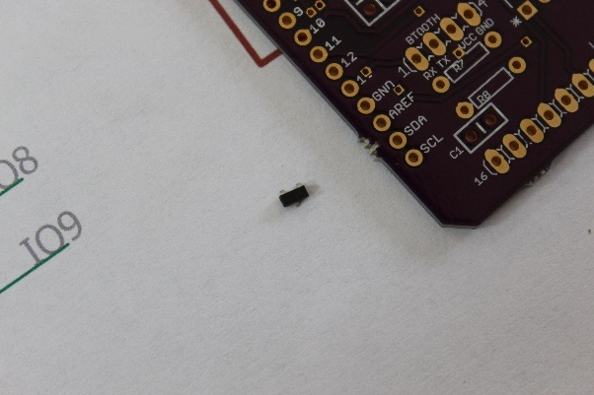

I start with the P-Fet because it is easier to solder it up without having to work around the headers and other components on the board. Check out a few tutorials on the web on soldering “surface mount” components. It isn’t too difficult if you’re patient. When you get through it, bask in the joy of knowing that you’ve tackled the hardest part of the entire build. FWIW, I solder it up by flowing a small amount of flux onto each of the three pads, then carefully placing the P-Fet onto the pad with some tweezers or pliers, then heating one leg to flow the solder onto the leg. Once the first leg is soldered, you can flow solder onto the other two. Hopefully yours will look cleaner than mine when you’re done, but know that even as ugly as this, it works.

It should be fairly obvious where it lives on the board and the orientation. The label might be slightly obscured, but it is labeled U2 and has 3 pads.

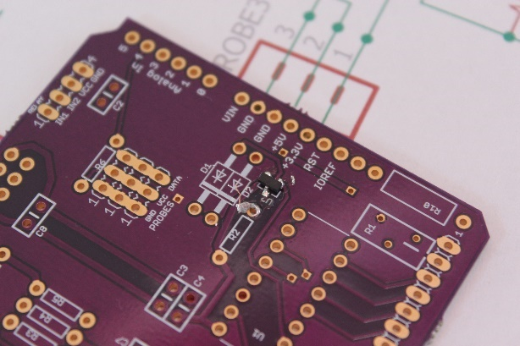

**Resistors**

With the P-F’er (as we lovingly call it in my house) behind you, let’s move on to the resistors. There is no orientation to the resistors, so put them in any fashion you desire. I solder them all up at the same time. Just put the leads into the holes and then bend the leads on the back in order to keep the resistor in place while you solder them up.

|  |  |  |
| --- | --- | --- |
| R2 – R5 | Resistor | 10k ¼ W |
| R6 | Resistor | 4.7k ¼ W |
| R7 | Resistor | 1K ¼ W |
| R8 | Resistor | 2K ¼ W |
| R9, R11 | Resistor | 220 ¼ W |
| R10 | Resistor | 20 ½ W |

Here’s what they look like before and after soldering. Trim the leads after you’ve soldered them all up.

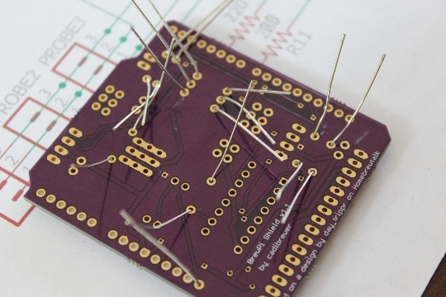

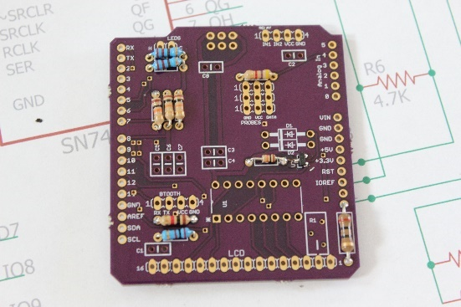

**Capacitors**

Soldering the capacitors is just like the resistors. No orientation, no problem. Put them in, bend the leads, solder them up. Make sure you get the largest capacitor in C8.

|  |  |  |
| --- | --- | --- |
| C1 – C7 | Capacitor | .1uF |
| C8 | Capacitor | 1.0uF |

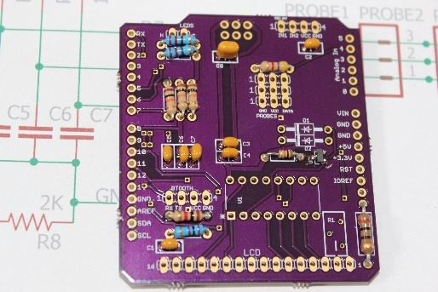

**Diodes**

The diodes have a polarized orientation. The silkscreen on the board has a heavy line and picture to help you orient them in the right direction. Solder them up like the resistors and capacitors.

|  |  |  |
| --- | --- | --- |
| D1 – D2 | Diode | 1N4007 |

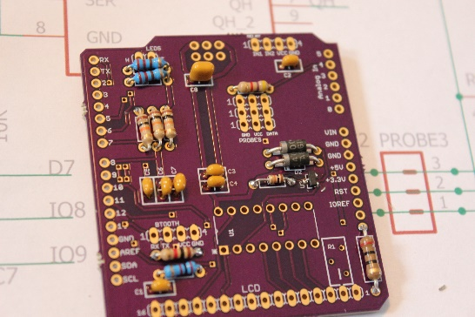

**Trimmer**

The trim pot goes in R1. If you ordered the right one, the legs will be offset and it will be apparent how to orient it in the slot. Solder it up.

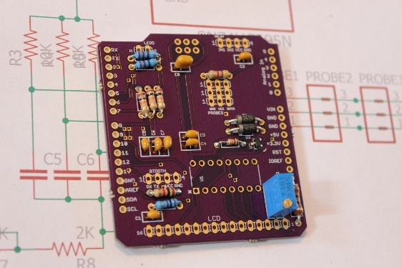

**IC Socket**

You can solder the IC right to the board, but I would suggest using a socket. Any 16 pin IC socket will work. There is a notch on the socket and a corresponding notch on the board silkscreen to help with orientation. Put the socket on the board and solder it up from the back.

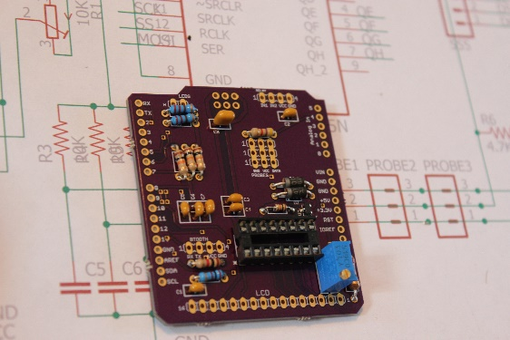

**Stackable Headers**

I used Arduino Stackable Headers, ordered from Adafruit.com. It would be better if you can find extra-long male pins so that you can use female socket jumper wires when you hook up the rotary encoder later on. If you use the stackable headers I used, you’ll have to use male jumper wires, which are taller and not as secure in their connection. Be smarter than I am.

Put the headers on the board and solder them up from the back. A trick I have found for getting them straight and aligned is to solder only one of the pins and then check the alignment. If it needs adjusting, simply heat the solder with your iron while moving the header with your other hand. You can reposition the header as you like and then let the solder cool. Then solder up the rest of the pins and you’ll have a straight installation.

**Note- The 6 pins in the 2x3 configuration need to be soldered from the top of the board so that your sockets are under on the back side. This is important because your board will not mate up with the Arduino Uno if you solder on the wrong side.**

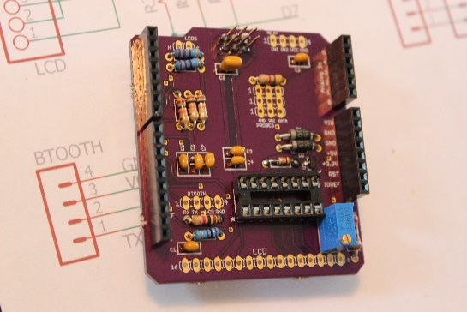

**Component Headers**

The headers for the LCD screen, Bluetooth, relay, probes, and LEDs are soldered in the same way. Cut the breakaway headers to the correct length using your diagonal cutting pliers. Solder them from the back with the long pins on the top of the board.

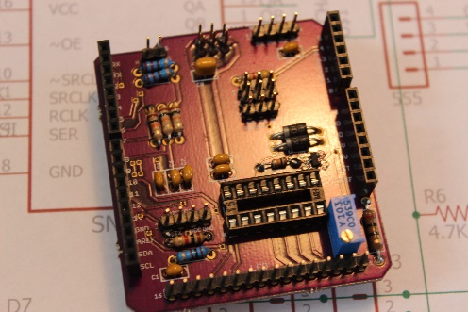

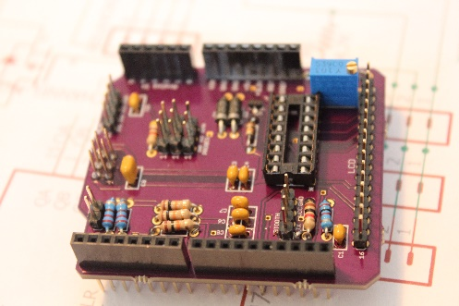

**Use**

That’s it, your board is done! You can insert the IC into the socket and then mate your new shield to your UNO. Hook up your LCD screen to the header and then adjust the brightness of the screen with the small screw on the trim pot.